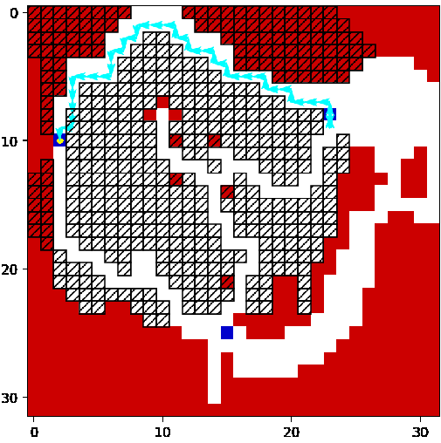

0 # Tour counter

1 # Successful Landing

91 # Current budget